

ICT PROJECT 1

WECARE MASSAGE AND THERAPHY

**DEVELOPERS**

* + - **Dinithi Vithanage**
    - **Xi ting jia**
    - **Shemal Ashen Jude Jayawardena Geekiyanage**
    - **Yu Liu**

# Executive Summary

The main aim of the following project was to redevelop and redesign the website presented during the beta release 1 based on the client’s requirements and during the client meetings as well.

As a part of the agile development methodology the project was divided into phases and the phases for the beta release part 2 was to get the initial cut out of the deigns including the form design which will then be further elevated in terms of designs for example, checks on consistency and proper responsiveness and dynamic login and booking online form.

The overall design which can be viewed within the screenshots and the difference between the beta1 release and the beta 2 release is more prominent due to the client’s feedback in providing the soothing and relaxing feel through the website itself. This included having better images to colour coordination, logo replacements, changes in navigation bar etc.

Git Hub was used as the main communication platform, overall as per the clients’ requirement.

Table of Contents

Executive Summary ii

1.0 Project Team Members 4

2.0 Beta Release Part 1 5

2.1 Beta Release- Iteration 1 5

2.2 Beta Release – Iteration 2 5

2.3 User Story 6

2.3 Beta Release- Iteration 2 7

2.4 Final Site map 8

2.5 Revised User Stories 9

2.5.1 Treatments Page Design Screenshot 10

2.5.2 Book Online Page Design Screenshot 12

2.5.3 Login Page Design Screenshot 12

2.5.4 Prices Page Design Screenshot 14

2.5.5 Contact Us Page Design Screenshot 15

2.6 Future Developments/Functionalities unable to be incorporated 17

3.0 Velocity and Burndown Charts 18

4.0 Final Phase User Stories 19

5.0 Final Release Prototypes 26

6.0 Project development and release ICT infrastructure 27

6.1 Configuration Management/ Version control 27

6.2 Project tools. Programming languages/IDEs 28

6.3 Link to Live Website 30

7.0 Appendix 31

7.1 Meeting Minutes 31

# 1.0 Project Team Members

As part of the continued agile methodology of Extreme Programming all team members mostly worked in pair programming and bug fixing. The team consisted of the following individuals:

* Dinithi Vithanage
* Xiting Jia
* Yu Liu
* Shemal Jayawardena

# 2.0 Beta Release Part 1

The beta release part 1 of the project is as follows and for the purpose of this report the changes made in each page in comparison to the beta release part 1 will be showcased against each user story as well

## 2.1 Beta Release- Iteration 1 Home Page

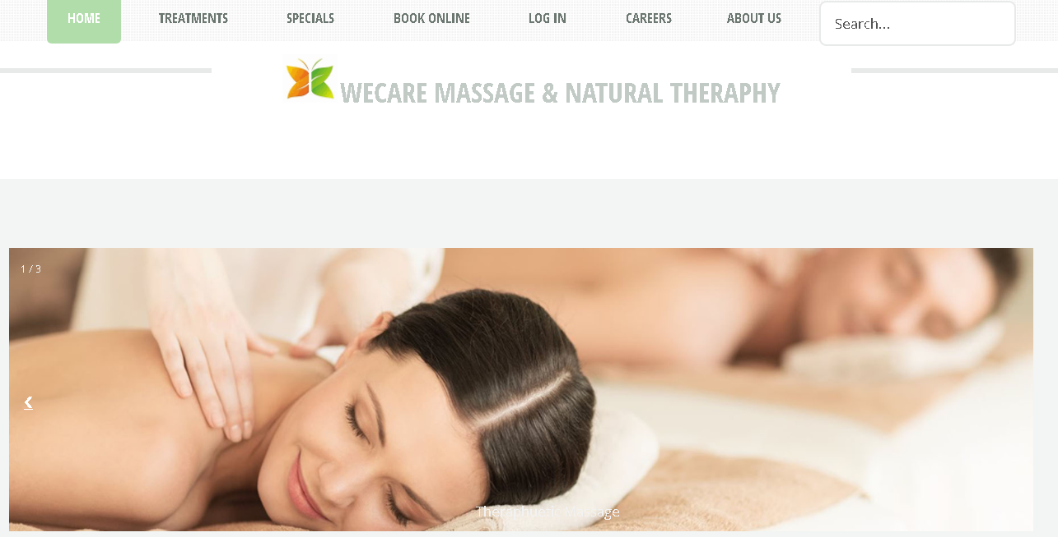

## 2.2 Beta Release – Iteration 2 HomePage

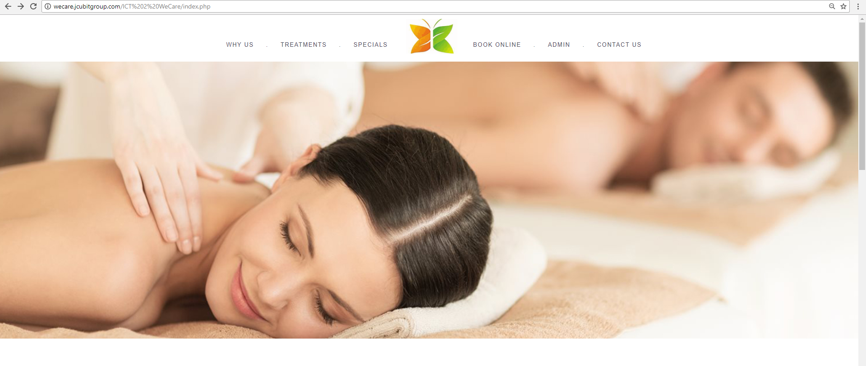

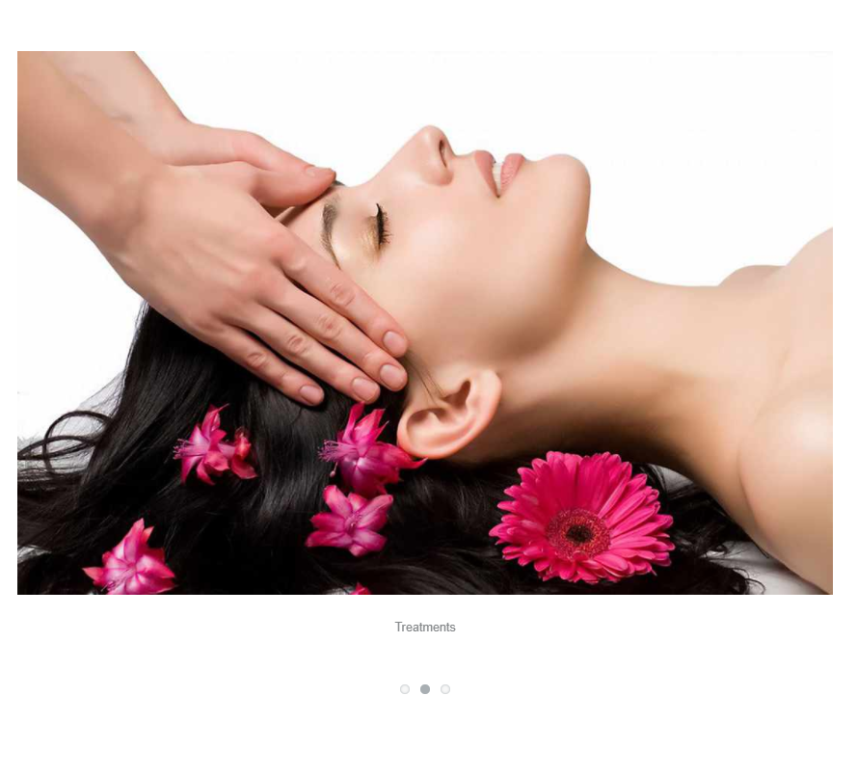 

## 2.3 User Story

**Title: Home Page and overall website**

**Description:**

**As a website visitor I would like to get an overall idea of the website at first glance with easy navigation**

**Acceptance Criteria:**

* **Navigation Bar Redesign (Important links first)**
* **Logo prominently in the middle**
* **Responsive Slideshow**

**Definition of complete/user acceptance:**

* **Slideshow change functionality**
* **Responsive website and images including slideshow**
* **Navigation menu functionality**

**Priority: Time estimate:**

10

5 Days

## 2.3 Beta Release- Iteration 2

Based on the feedback received from the beta release iteration 1 the following changes were recommended by the client and a few changes were added on by the team as well in order to better the look and feel of the website.

* **Slideshow Images**

Although the 1st beta release included slideshow images, the team decided to further improve the slideshow by adding a larger image that best mimics the relaxing and soothing atmosphere within the WeCare Massage premises in order to entice the website visitors right from the get go.

* **Minimalistic Design**

The website did have a very minimalistic design however, this was taken a step further during the beta iteration 2 where the client recommended to keep a very soft font and communicate via a more structured image gallery.

* **Website colour scheme**

The green, white and orange colour concept was to be remained through the entire site as per the first Meeting Minutes. **(Refer Meeting Minutes****-Appendix 1****)**

* **Website sitemap changes**

The client requested for the rearrangement of the main links of the website as well as the placement of the logo for a more professional look onto the site. In addition, the requested careers page was added on to the footer and a contact us page along with an about us or why us page was added.

**(Refer Image 1 below)**

## 2.4 Final Site map

**The final sitemap based on clients requested changes was finalized and locked down for the last phase of the project as follows:**

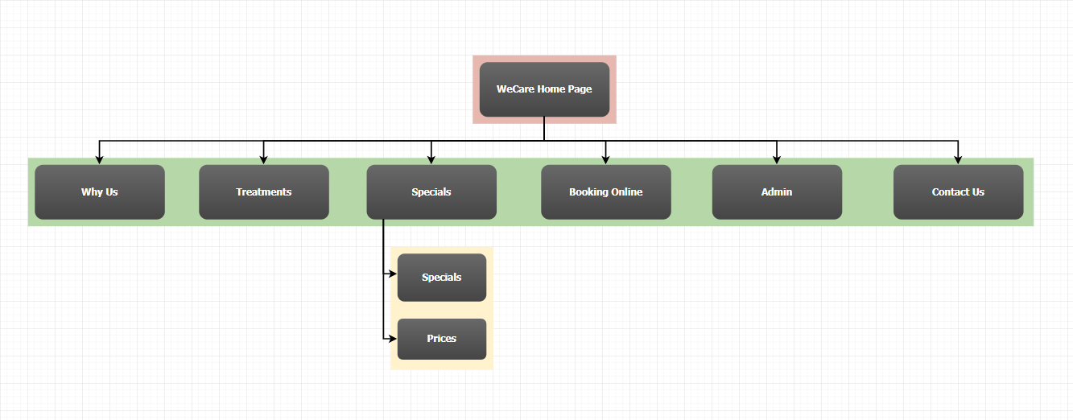

Figure 1 : Finalized Site Map

## 2.5 Revised User Stories

Each of the user stories created for the beta phase 2 are as follows followed by the screen shot image of the actual design to support the user story.

### 2.5.1 Treatments Page Design Screenshot

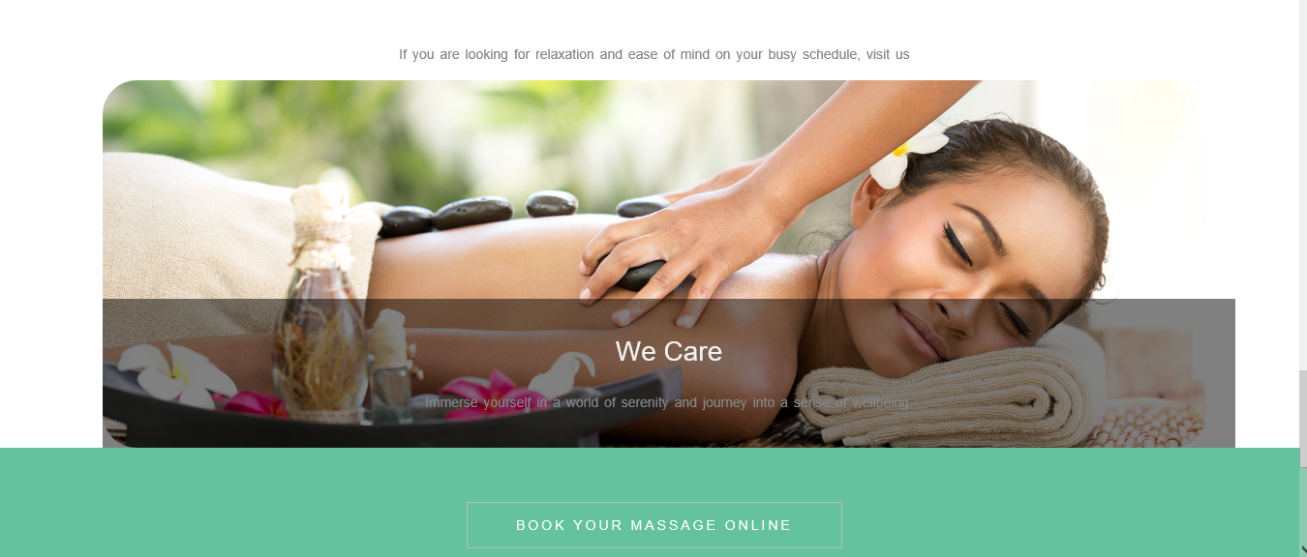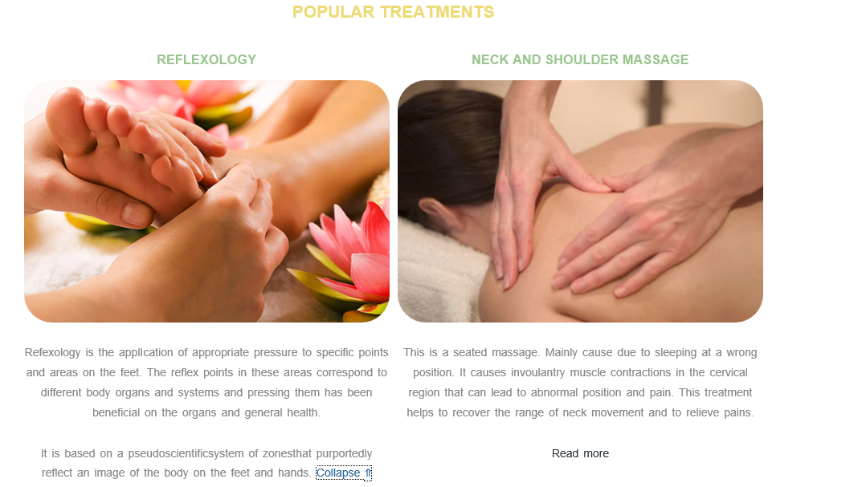

**Title: Treatments**

**Description:**

**As a website visitor I would like to get an overall idea of the website at first glance with easy navigation**

**Acceptance Criteria:**

* **Reorder treatment featuring the most popular on a grid format**
* **Treatment details to be followed by a read more link**
* **Creative picture layout at the bottom of the page- grid image layout**
* **Scrolling text of Spa features. E.g. Stress Free, Relaxation**

**Definition of complete/user acceptance:**

* **Read More button functioning well**
* **Content on treatments accurate**

**Priority: Time estimate:**

10

5 Days

### 2.5.2 Book Online Page Design Screenshot

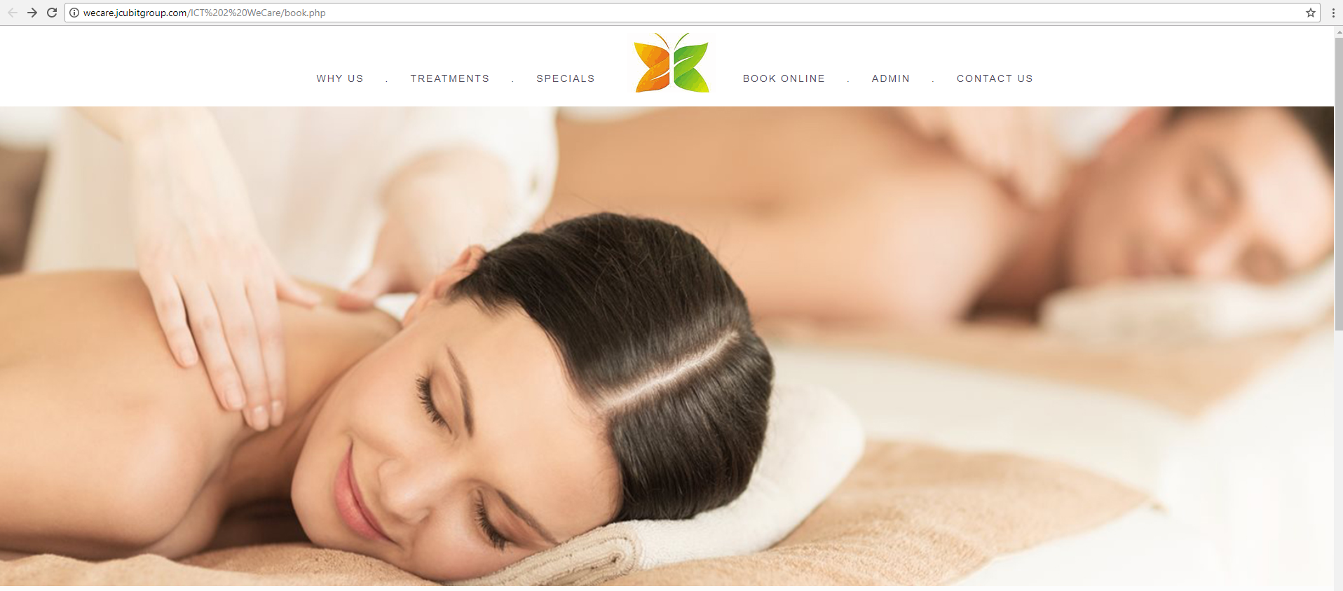

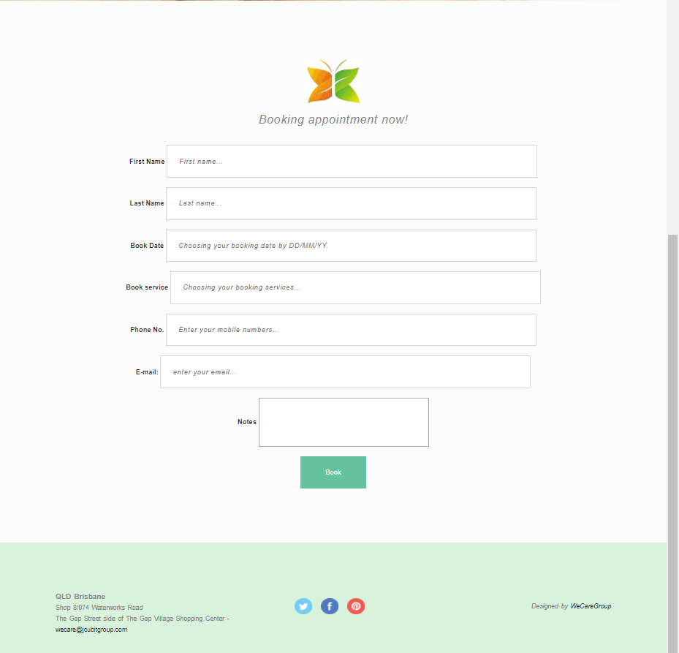

### 2.5.3 Login Page Design Screenshot

**Title: Book Online**

**Description:**

**As a website visitor I would like the form fields to be aligned properly with all the relevant fields layout clearly and responsive to all devices**

**Acceptance Criteria:**

* **Basic Design of the form plus database fields in relation to the forms designed on the database**

**Definition of complete/user acceptance:**

* **Entire form designed in a simple manner with all relevant fields present**
* **Form to be responsive**
* **Form fields entered onto the database.**

**Priority: Time estimate:**

10

6 Days

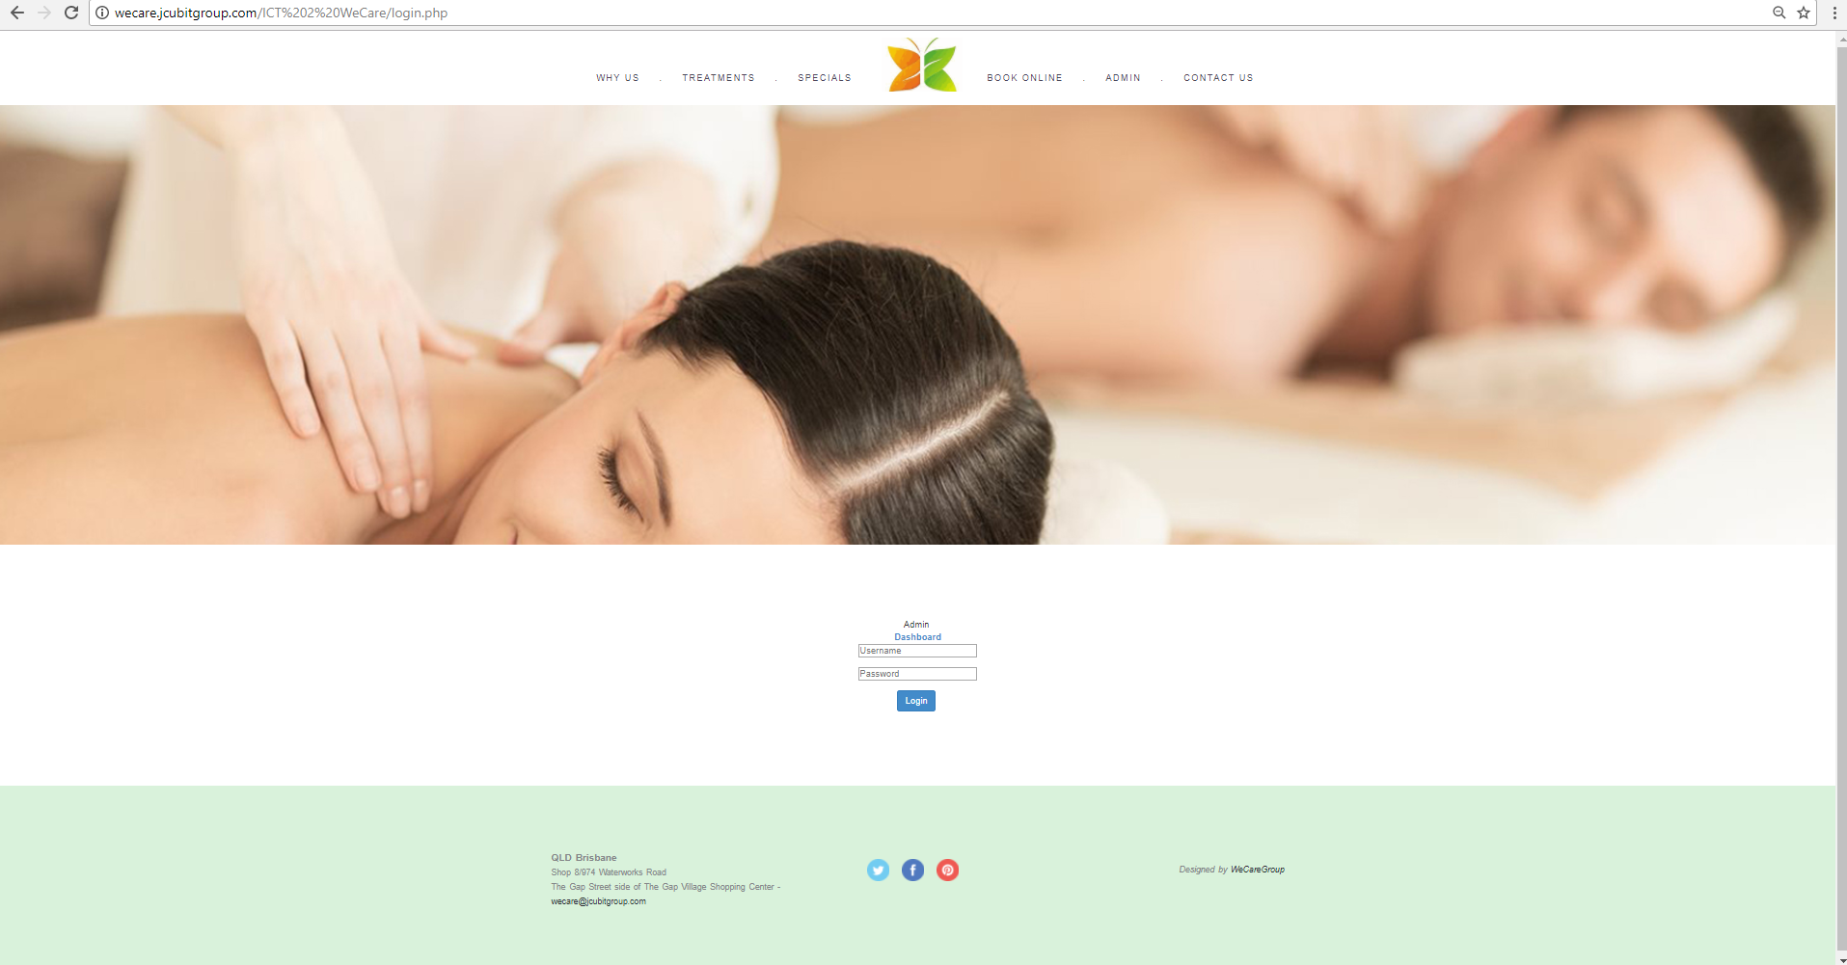

10

4 Days

**Title: Login Page**

**Description:**

**As a website visitor I would like the form fields to be aligned properly with all the relevant fields layout clearly and responsive to all devices**

**Acceptance Criteria:**

* **Basic Design of the form plus database fields in relation to the forms designed on the database**

**Definition of complete/user acceptance:**

* **Entire form designed in a simple manner with all relevant fields present**
* **Form to be responsive**
* **Form fields entered onto the database.**

**Priority: Time estimate:**

### 2.5.4 Prices Page Design Screenshot

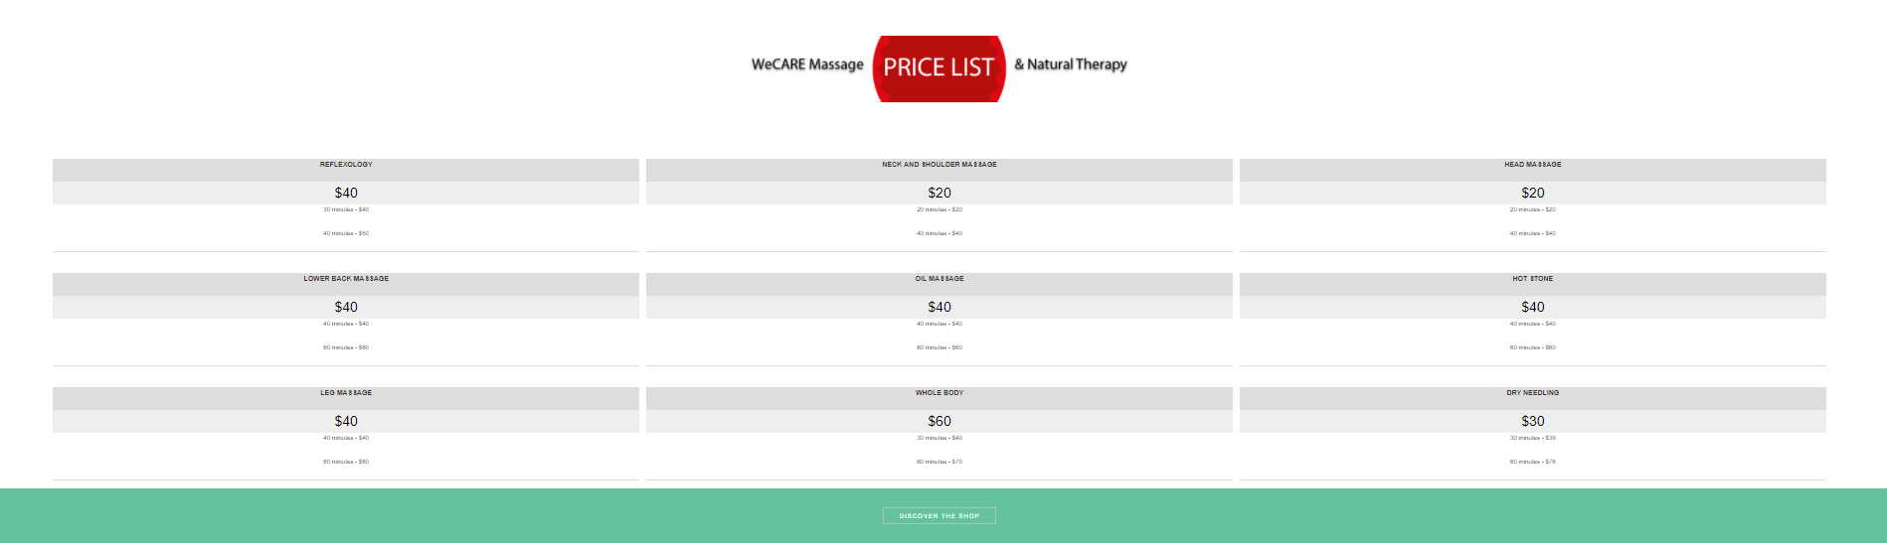

**Title: Prices Page**

**Description:**

**As a website visitor, I would like to view a concise price sheet along with every treatment and massage available.**

**Acceptance Criteria:**

* **Clear and Concise prices display**
* **Successful links to book online page**

**Definition of complete/user acceptance:**

* **Consistency in image alignment and content alignment**
* **Read More function in places of large descriptions**
* **Passes test of UI team**

**Priority: Time estimate:**



### 2.5.5 Contact Us Page Design

This was how the Contact Us page appeared before the 2nd Iteration –

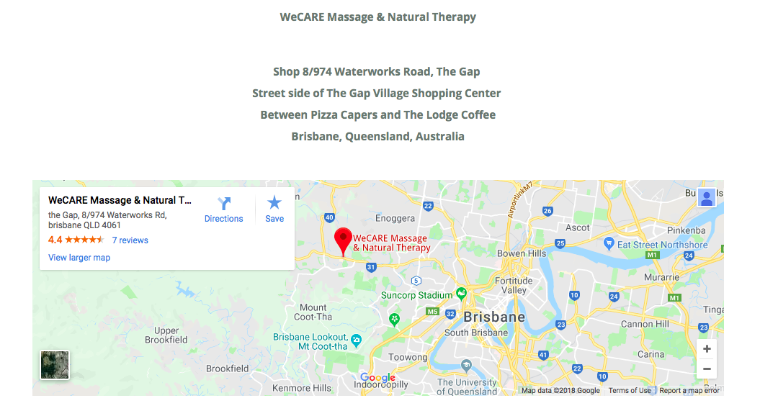

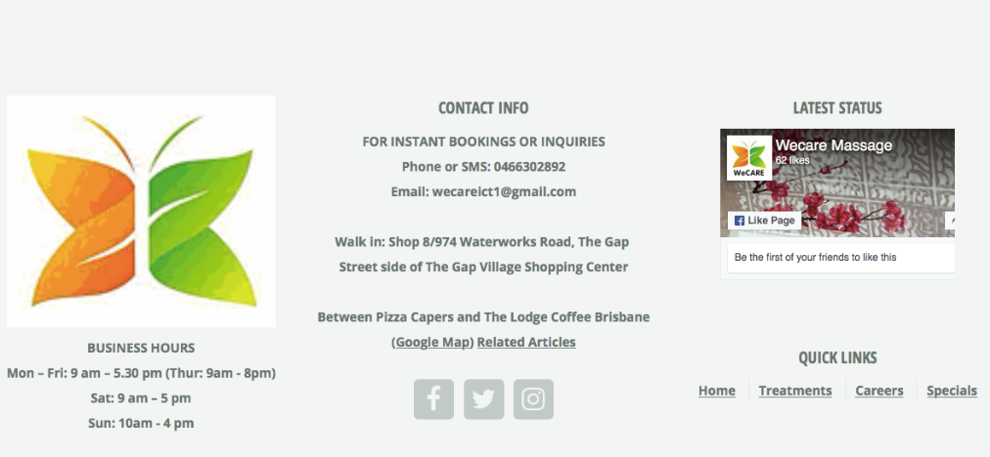

Screenshots of the current Contact us page -

 

**Title: Contact us Page**

**Description:**

**As a website visitor, I would like to view a larger map with a prominent placement on the navigation bar for the contact us page which was not provided in the beta release 1**

**Acceptance Criteria:**

* **Clear and Concise contact details**
* **Larger Google Maps design as discussed during the client meeting**
* **Quick links to social media pages like Facebook, Twitter and Instagram**
* **Latest status and the current activities on the status panel of the social media segment**
* **Working hours made simple and concise as discussed with client**

**Definition of complete/user acceptance:**

* **Consistency in image alignment and content alignment**
* **Read More function in places of large descriptions**

**Priority: Time estimate:**

3Days

10

## 2.6 Future Developments/Functionalities unable to be incorporated

Since the entire site has been revamped from beta release 1 the final release or future developments will be adding features such as a consistent look and feel with relevant fonts picked out by the client and the development team as well as a crisp and clean design based on new design trends.

**Booking Online**

The client requested the book online form to be quite simplistic and easy to obtain information about client bookings and the design discussed is as per the final prototype looks given at the end of the assignment. The previous design of the contact us form during the beta 1 release was quite complex and required users to scroll through 2 to 3 pages prior to making the bookings, therefore for this purpose the current booking online form is a one-page form that allowed for ease of use.

**Log in Page**

The login page would be a simple page with validation that allows for admin to view the bookings made, delete any boking and edit information within the login page.

Furthermore, the main requirement of the final stage of the client is to showcase a very modern yet simple website that relays the soothing interior and overall business objectives of the client.

The about us page was added in order to provide the client a look into the staff members working in the store and ensuring that they relay the homely feeling of this family owned business.

The final release will include the database connectivity section as there is a larger area to finish after the overall redesign of the website.  Refer Final Phase User Stories

# 3.0 Velocity and Burndown Charts

|  |  |  |  |  |  |
| --- | --- | --- | --- | --- | --- |
|  |  |  | **ESTIMATED** | **ACTUAL** |  |
| **Beta Release Part 2** | **1** | Overall Website redesign | 1 | 1 | **VELOCITY** |
| Responsive features | 1 | 2 |
| Navigation Bar | 1 | 1 |
| Slideshow incorporation | 1 | 1 |
| Home Page Design | 1 | 1 |
| **2** | Treatments Page | 1 | 1 |
| Grid Format Organization | 1 | 1 |
| Grid and Image responsiveness | 1 | 1 |
| Read More features | 1 | 1 |
| Picture Grid | 1 | 1 |
| **3** | Booking Page Creation | 6 | 6 |
| **5** | Login Page | 4 | 5 |
| **6** | Prices Page | 4 | 4 |
| **7** | Contact Us Page | 3 | 3 |
|  |  | **27** | **29** | **0.931034483** |

# 4.0 Final Phase User Stories

|  |  |  |  |  |  |  |
| --- | --- | --- | --- | --- | --- | --- |
| **Release** | **Nr** | **User Story** | **Description** | **Priority** | **Time (days)** | **Status** |
| **FINAL RELASE** | 1 | **HOME PAGE AND OVERALL WEBSITE** | Music with functionality to stop | 10 | 4 | TO BE COMPLETED |
| **5 Weeks** | 2 | Link to prices of entire treatment list | 10 | 2 | TO BE COMPLETED |
| 3 | More treatments added on a collapsing panel | 10 | 2 | TO BE COMPLETED |
| 4 | Connection to the database and enable staff to update details from the back end | 10 | 4 | TO BE COMPLETED |
| 5 | Validation of entry fields | 10 | 4 | TO BE COMPLETED |
| 6 | Entire Functionality within website | 10 | 2 | TO BE COMPLETED |
| 7 | Careers Page | 10 | 4 | TO BE COMPLETED |
| 8 | **TESTING AND DELIVERY** | Develop Test Cases for each form and field | 10 | 4 | TO BE COMPLETED |
| 9 | **BUG FIXES** | Admin Pages | 10 | 4 | TO BE COMPLETED |
|  | 10 | **MARKETING** | SEO for the main pages, including title tags, meta description and keywords | 9 | 3 | TO BE COMPLETED |

**Title: Home Page and overall website**

**Description:**

**As a website visitor I would like to get an overall idea of the website at first glance with easy navigation**

**Acceptance Criteria:**

* **Music with functionality to stop**

**Definition of complete/user acceptance:**

* **Music button to stop playing when user wills for usability**

**Priority: Time estimate:**





**Title: Treatments**

**Description:**

**As a website visitor I would like to get a glance of the popular treatments then have a view of all the treatments and be able to be linked on to the book online page or contact us page.**

**Acceptance Criteria:**

* **Link to prices of entire treatment list**
* **More treatments added on a collapsing panel**

**Definition of complete/user acceptance:**

* **Read More button functioning well**
* **Prices organized in an orderly manner**
* **Content on treatments accurate**

**Priority: Time estimate:**

4 Days

10

**Title: Book Online**

**Description:**

**As a website visitor I would like to book an appointment with ease with a one-step booking process making the process easy and quick.**

**Acceptance Criteria:**

* **Validation of entry fields**
  + **Validating phone number etc**
* **Generate success and failure message after processing**

**Definition of complete/user acceptance:**

* **Data Entry to be saved to database properly**
* **Passes test of UI team**

**Priority: Time estimate:**

4 Days

10

**Title: Careers Page**

**Description:**

**As a website visitor, the client would like to see the different careers showcased along with the qualifications required. Contact information such as email should be linked on this page so that the client can simply click on the e-mail and apply for the particular job**

**Acceptance Criteria:**

* **Clear and Concise careers block display**
* **Successful click to email option on click of email**

**Definition of complete/user acceptance:**

* **Consistency in image alignment and content alignment**
* **Read More function in places of large descriptions**
* **Passes test of UI team**

**Priority: Time estimate:**



**Title: Login Page**

**Description:**

**As a website visitor I would like to login with ease and be popped up with any incorrect login detail information**

**Acceptance Criteria:**

* **Validation of entry fields**
  + **Validating phone number etc**
* **Generate success and failure message after processing**

**Definition of complete/user acceptance:**

* **Data Entry to be saved to database properly**
* **Passes test of UI team**

**Priority: Time estimate:**

4 Days

10

**Title: Admin Pages**

**Description:**

**As a website user I would like to edit and delete details of the client bookings with ease and be able to view the correct details of clients based on validated fields**

**Acceptance Criteria:**

* **Edit Client booking details**
* **Delete Client booking details**

**Definition of complete/user acceptance:**

* **Data Entry to be saved to database properly**
* **Passes test of UI team**

**Priority: Time estimate:**



# 5.0 Final Release Prototypes

The book online form would be our number one priority and therefore the elevated design would be as follows with validated fields and mandatory fields.

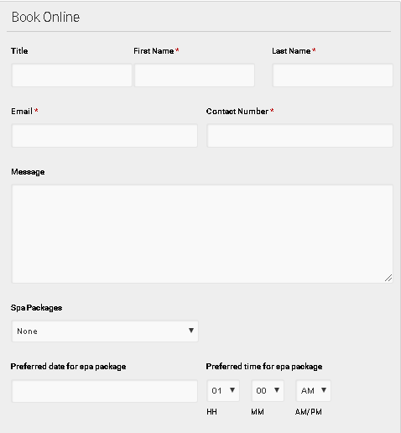

# 6.0 Project development and release ICT infrastructure

## 6.1 Configuration Management/ Version control

* GitHub to record every step of website designs help remember and recover all the previous data files if needed.

GitHub Repository link: <https://github.com/jc444921/ICT-Project-1>

Given below is a screenshot of the Git Hub Project management tool used for all communication.

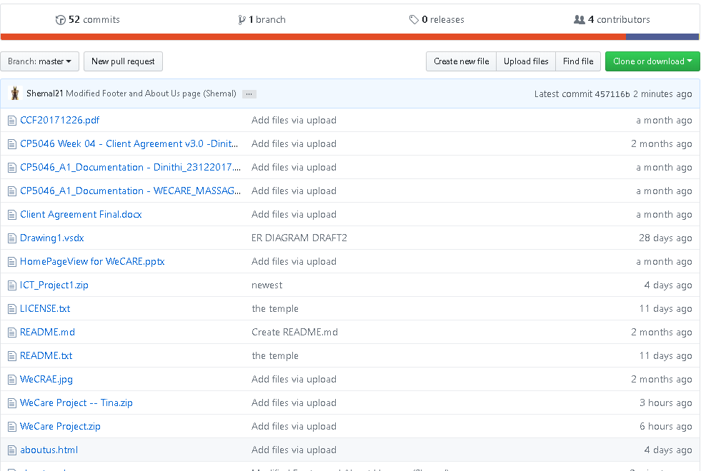

* SLACK and WhatsApp for community and discussing our project and make communication easy with clients.

## 6.2 Project tools. Programming languages/IDEs

:

o Dreamweaver as basic designing tools for WeCare.

o PHP for all global part control, like navigation bar, which will be in every page, this will provide easy edits and changes in the future.

o SQL, WeCare website need database system to recording clients detail.

o HTML5 for basic designing, after the completion of the main 3 or 4 pages, the files will be changed to html files to PHP style.

o Bootstrap used for easy design among the website

* JavaScript used for read more functionality and navigation functionality

EXAMPLES OF JAVA SCRIPT

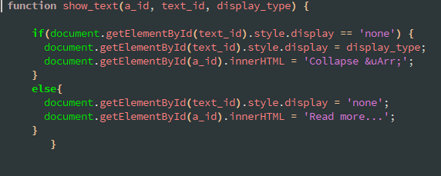

The above java script is an example of what was used in the site, this was mainly used in the Read More section in the Treatments Page

EXAMPLES OF CSS

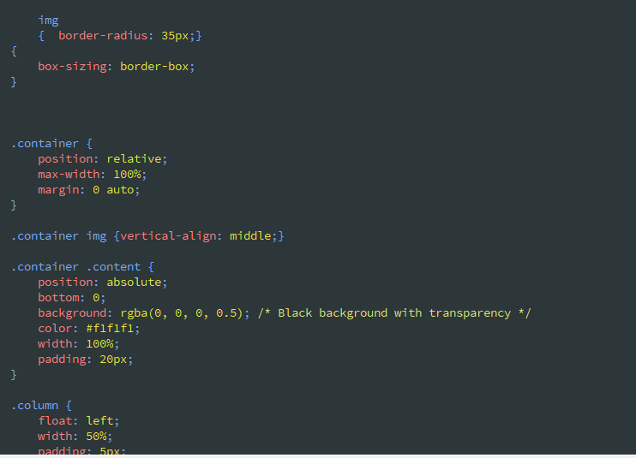

EXAMPLE OF USE OF BOOTSTRAP

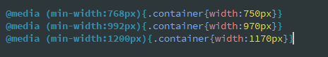

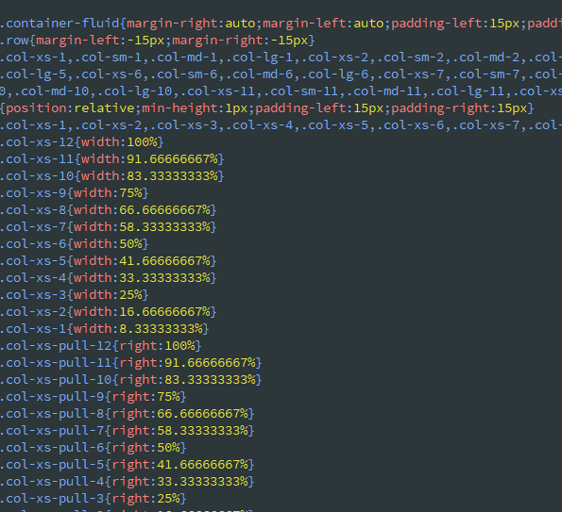

The following was the code used for the slideshow which was one of the main requirements from the client.

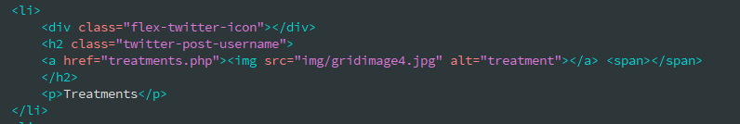 The above is an example of the HTML coding used for various sections of the site, this example being our treatments in order to make the websites more structural.

## 6.3 Link to Live Website

http://wecare.jcubitgroup.com/ICT%202%20WeCare/treatments.php

# 7.0 Appendix

## 7.1 Meeting Minutes

| Accent icon | Meeting Minutes |
| --- | --- |

**Call to order**

A meeting of **WeCare Massage and Therapy** was held at S**hop 8/974 Waterworks Road, The Gap, Street side of The Gap Village Shopping Centre** on **17th April 2018**

**Attendees**

Attendees included

* Yu Liu
* Xi ting jia
* Shemal Jayawardena
* Dinithi Vithanage
* Michael Yang (Client)

**Members not in attendance**

All Members Present

**Reports**

* With the approval of the client the sitemap and current design for beta phase 2 below was finalized and included in the initial client agreement.
* The pages were to remain similar to the current pages however, new pages to be added includes:
  + Careers
  + Book Online- Dynamic function
  + Log in- -Dynamic function
  + Treatments and other remedial pages to be more informative and spread across the site in a methodical manner as the current site design was busy in nature.

|  |  |  |
| --- | --- | --- |
| * **Dinithi Vithanage** |  | * **17th April 2018** |
| **Secretary** |  | **Date of approval** |